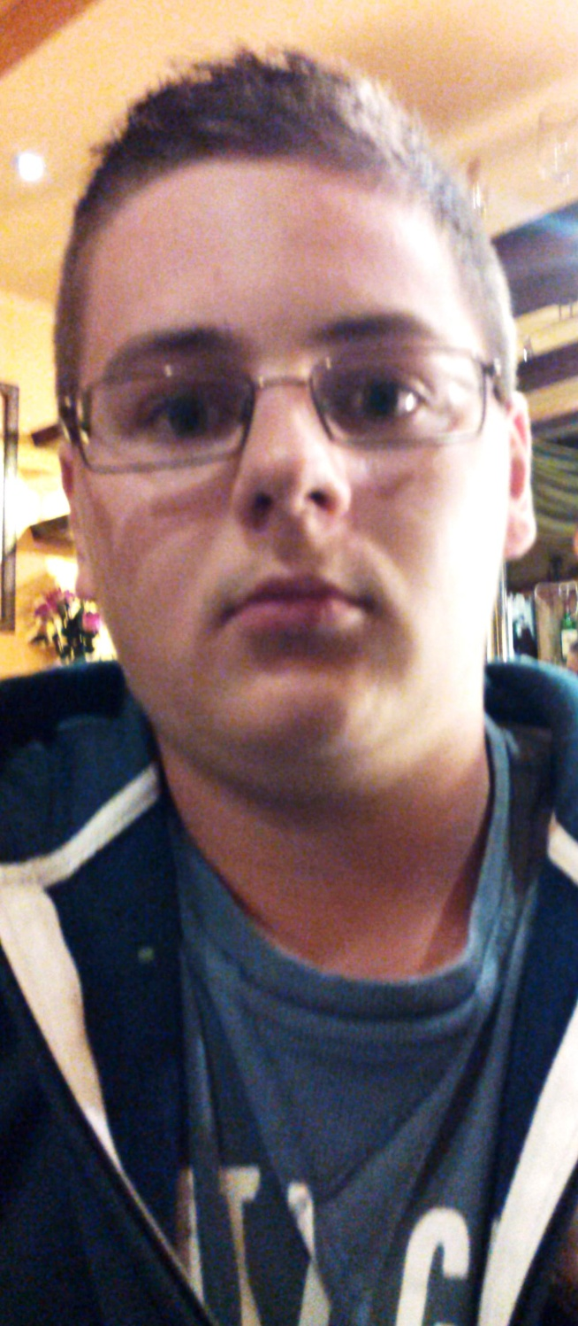

Hello everybody,

My name is Tomáš Strakuľa. I come from Slovakia, especially from the middle sized village under the High Tatras. I´m 16 years old and I was born in August 1999.

Family: We are complete family. My parents are middle-aged. I have one sister and she is 7. I study on Secondary Technical School in profession Electrotechnics – Informating and telecomunicating systems. I visit second class.

My hobbies are listening to loud rock music, skiing, biking, football, programming, computer games, writing the poems, making something outside. I´m chatty, friendly, polite, honest, I love cosy places but hate shopping.